Fundamentals of Database Technologies

Assignment 4

Name: Qian Zhang

CID: 01939418

Date: 11/10/2020

# Step 1

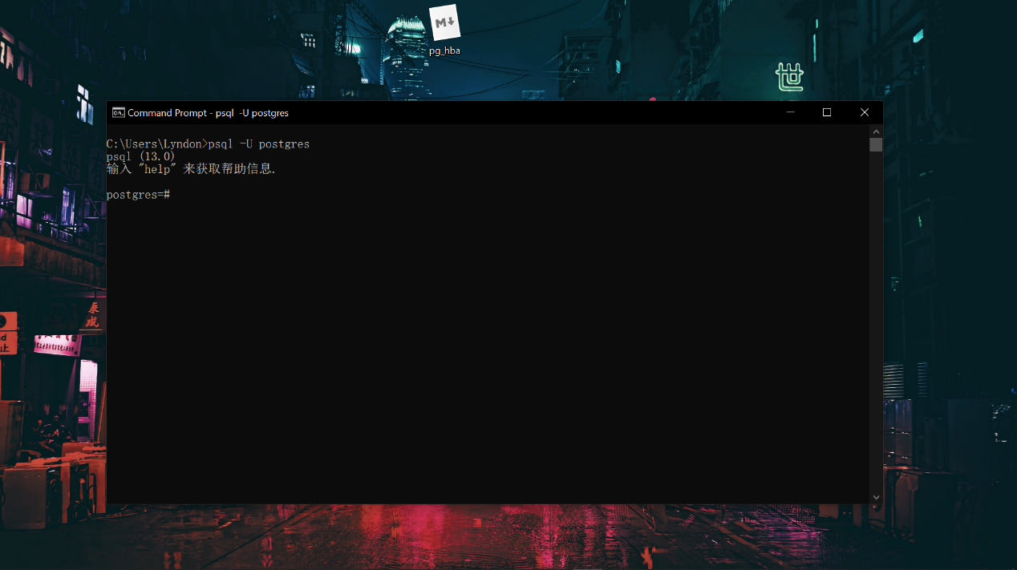

# Step 2

This CSV file is a collection of dishes and their corresponding attiribtues, collected from 4500s menus from 1840s to the present. It includes the name of every dish with an unique ID, and corresponding numbers of appearance on menus and the time of appearances. It also includes the date of first appearance, the date of last appearance, the lowest price and the highest price for every dish.

# Step 3

# 

# Step 4

# 

# Step 5

CREATE TABLE dish_table(

dish_id int PRIMARY KEY,

name text,

menus_appeared int ,

times_appeared int,

first_appeared int,

last_appeared int,

lowest_price float,

highest_price float

);

# Step 6

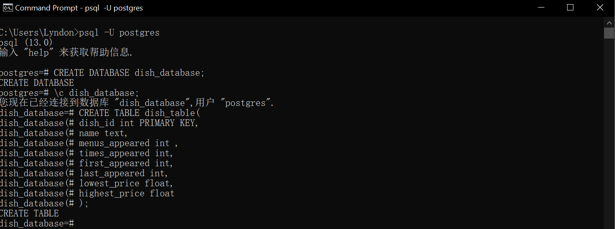

# Step 7,8

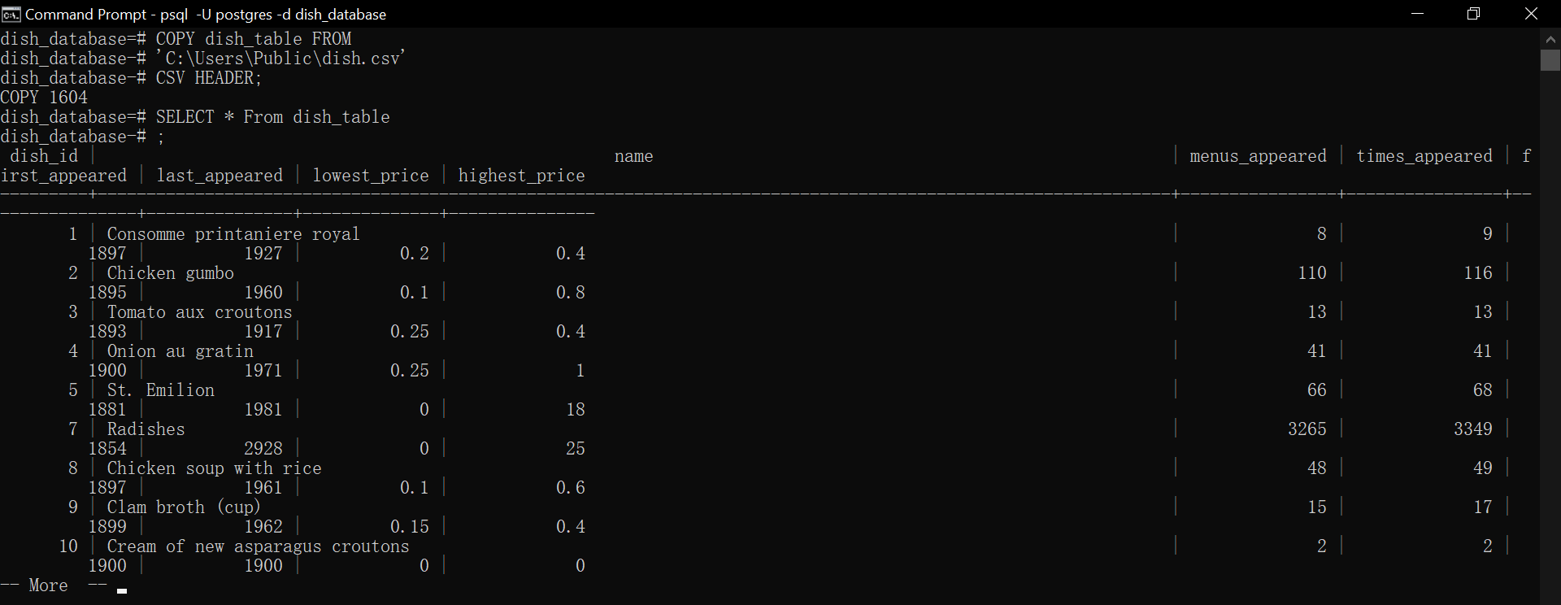

# Step 9

quary 1:

I want to search for the dishes that first appeared after 1900, and display the corresponding dish_id, name and the date of first_appeared,

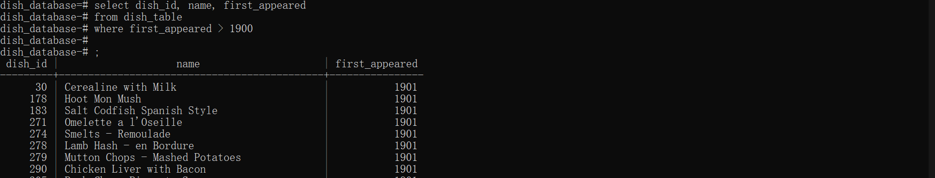

select dish_id, name, first_appeared

from dish_table

where first_appeared > 1900;

quary 2:

I want to search for the average highest price of all dishes in each year after 1850.

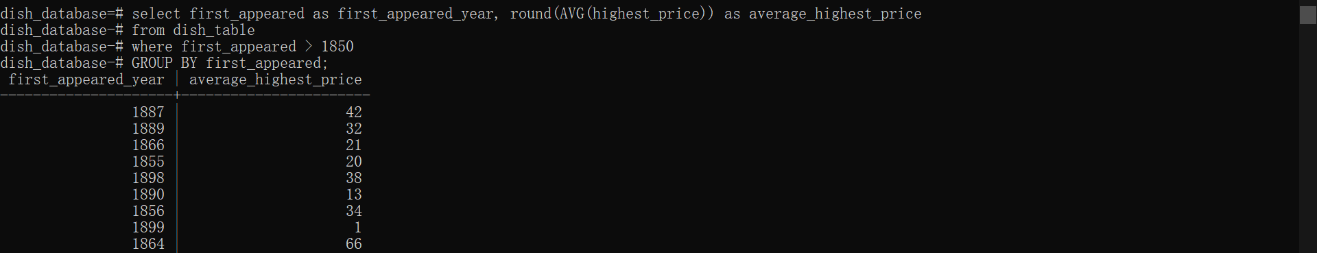

select first_appeared as first_appeared_year, round(AVG(highest_price)) as average_highest_price

from dish_table

GROUP BY first_appeared;

quary 3:

For all the dishes that first appeared after 1850, I want to display the dish_id, highest_price, and the average highest pirce of all dishes in this year.

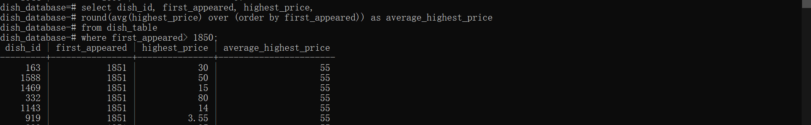

select dish_id, first_appeared, highest_price,

round(avg(highest_price) over (order by first_appeared)) as average_highest_price

from dish_table

where first_appeared> 1850;

# Step 10

I want to search for the dishes that only appeared on the menus for less than 30 years, which are considered as unpopular dishes, and display dish_id, name, first_appeared and last_appeared.

create table unpopulars_dishes

as (

select dish_id,name,first_appeared,last_appeared

from dish_table

where (last_appeared-first_appeared) < 30);

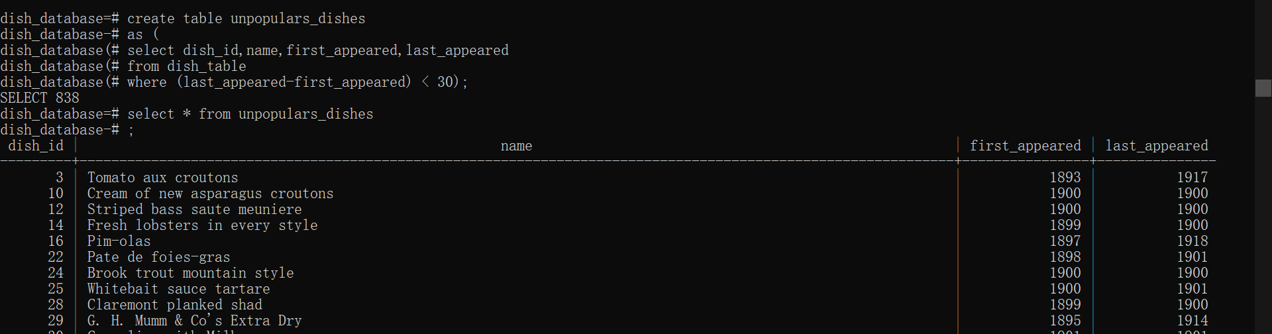

# Step 11

